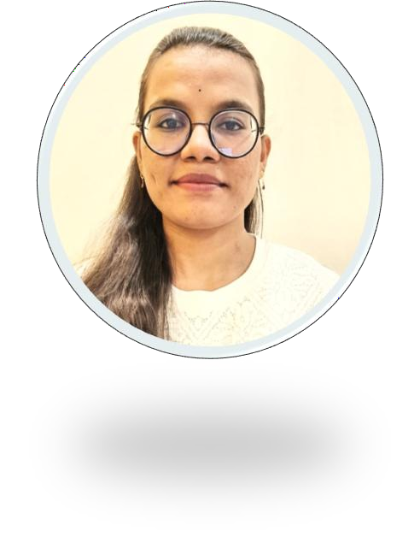ABHINAYA SIRSANAGANDLA

# CONTACT

PHONE:

9603722981

WEBSITE:

LinkedIn: https://[www.linkedin.com/in/abhi-](http://www.linkedin.com/in/abhi-) sharma-6a81962a7

EMAIL:

abhinayasharma121gmail.com

# TECHNICAL SKILLS

### Programming Language:

C , java

### Web Technologies:

HTML,CSS,JS

### Databases:

Sql,mysql

### Operating Systems:

MS Dos , Linux

### Tools:

Power BI , tableau,vs code

# SKILLS

Quick learning Problem solving

Good communication adoptive

## EDUCATION

BTech , Computer science engineering

Krishna Chaitanya Institute of Technology and Sciences , Markapur CGPA : 8.33

Senior secondary , Andhra Pradesh ,state board Sri sadhana junior college, Markapur Percentage : 87%

Secondary(X),Andhra Pradesh, state board Sri sai Chaitanya high school , Markapur CGPA : 9.7

## PROJECTS

#### Web development

Recipe making -”Developed an interactive recipe-making project showcasing culinary creativity and step-by-step instructional design." Zomato web page-"Designed and developed a functional replica of the Zomato webpage, incorporating UI/UX principles and responsive web design using HTML,CSS,JS."

## INTERNSHIPS

#### Data science

Internship on data science in period od November ,2024.

## CERTIFICATES

Python programming certificate Data science certificate

**Declaration**

I here by declare that the information furnished above is true to the best of my knowledge and I believe.

Abhinaya.S